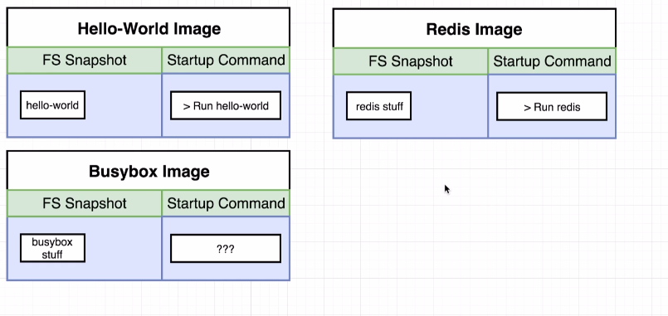
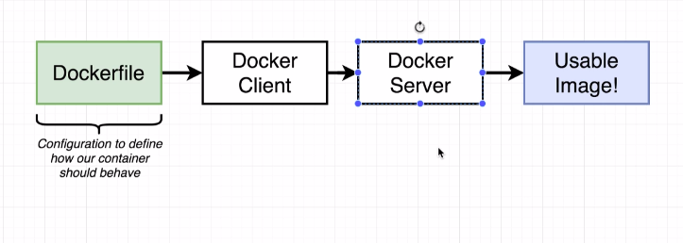
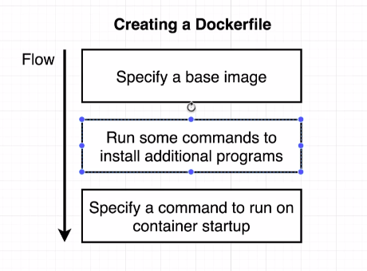

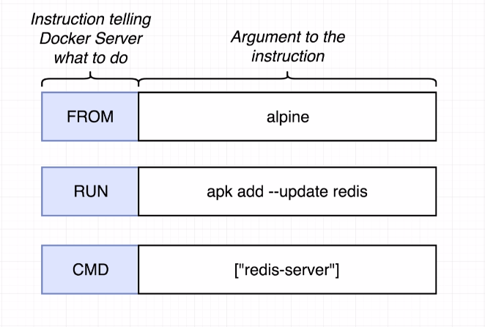

geekarea@geekarea-Inspiron-7559:~/redis-image$ docker build .
Sending build context to Docker daemon 2.048kB
Step 1/3 : FROM alpine
---> a24bb4013296
Step 2/3 : RUN apk add --update redis
---> Running in 202a22b42738
fetch http://dl-cdn.alpinelinux.org/alpine/v3.12/main/x86_64/APKINDEX.tar.gz
fetch http://dl-cdn.alpinelinux.org/alpine/v3.12/community/x86_64/APKINDEX.tar.gz
(1/1) Installing redis (5.0.9-r0)
Executing redis-5.0.9-r0.pre-install
Executing redis-5.0.9-r0.post-install
Executing busybox-1.31.1-r16.trigger
OK: 7 MiB in 15 packages
Removing intermediate container 202a22b42738
---> d988758feb4f
Step 3/3 : CMD [ "redis-server" ]
---> Running in 580c147a685d
Removing intermediate container 580c147a685d
---> 7e95c822ee25
Successfully built 7e95c822ee25

geekarea@geekarea-Inspiron-7559:~/redis-image$ docker run 7e95c822ee25
1:C 10 Jun 2020 08:36:56.736 # oO0OoO0OoO0Oo Redis is starting oO0OoO0OoO0Oo
1:C 10 Jun 2020 08:36:56.736 # Redis version=5.0.9, bits=64, commit=869dcbdc, modified=0, pid=1, just started
1:C 10 Jun 2020 08:36:56.736 # Warning: no config file specified, using the default config. In order to specify a config file use redis-server /path/to/redis.conf
1:M 10 Jun 2020 08:36:56.738 * Running mode=standalone, port=6379.
1:M 10 Jun 2020 08:36:56.738 # Server initialized
1:M 10 Jun 2020 08:36:56.738 # WARNING overcommit_memory is set to 0! Background save may fail under low memory condition. To fix this issue add 'vm.overcommit_memory = 1' to /etc/sysctl.conf and then reboot or run the command 'sysctl vm.overcommit_memory=1' for this to take effect.
1:M 10 Jun 2020 08:36:56.738 # WARNING you have Transparent Huge Pages (THP) support enabled in your kernel. This will create latency and memory usage issues with Redis. To fix this issue run the command 'echo never > /sys/kernel/mm/transparent_hugepage/enabled' as root, and add it to your /etc/rc.local in order to retain the setting after a reboot. Redis must be restarted after THP is disabled.
1:M 10 Jun 2020 08:36:56.738 * Ready to accept connections
580c147a685d

Alpine Linux is a Linux distribution built around musl libc and BusyBox. The image is only 5 MB in size and has access to a package repository that is much more complete than other BusyBox based images. ... Read more about Alpine Linux here and you can see how their mantra fits in right at home with Docker images.

apk add bash: tells Docker to install bash into the image. apk stands for Alpine Linux package manager. If you're using a Linux base image in a flavor other than Alpine, then you'd install packages with RUN apt-get instead of apk.

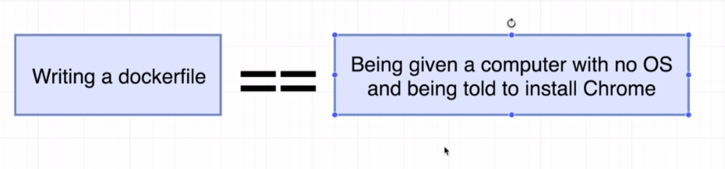

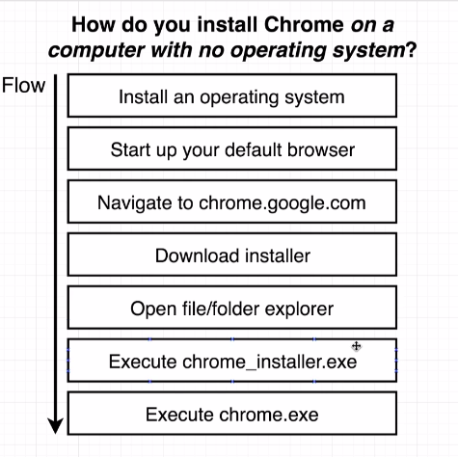

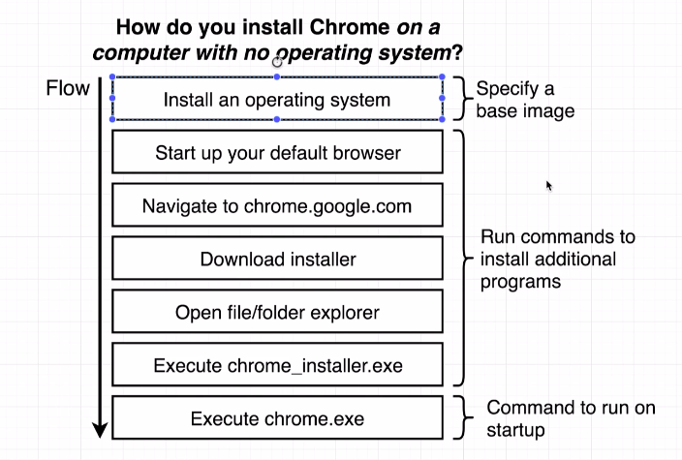

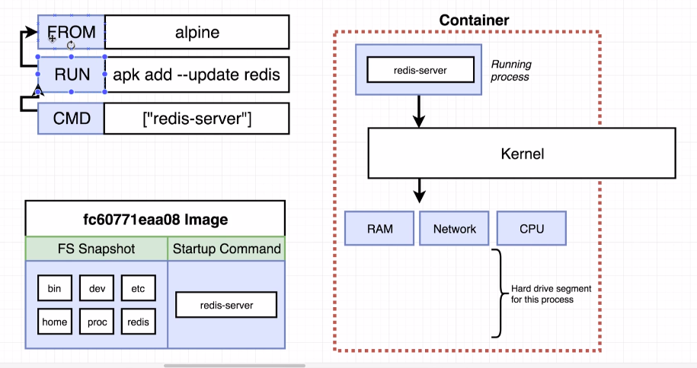
Build of image file :

Create new image after each and every step of build steps:
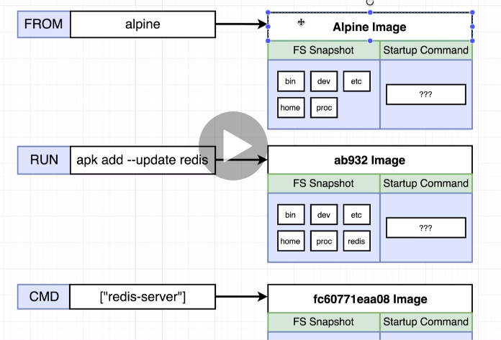

Rebuild of docker-file will use cache to rebuild docker-file if we change order in docker-file, impact on caching function.

Tagging an Image :

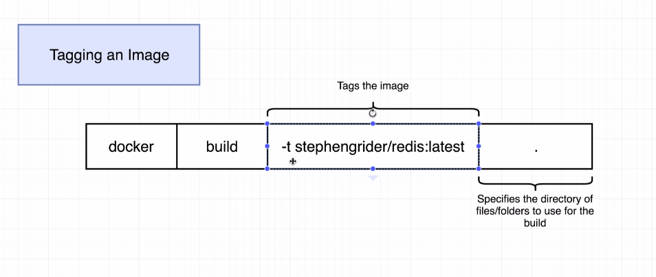

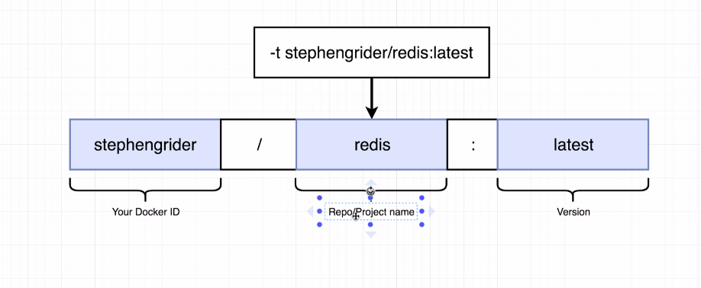

geekarea@geekarea-Inspiron-7559:~/redis-image$ docker build -t stephengrinder/redis:latest .
Sending build context to Docker daemon 2.048kB
Step 1/4 : FROM alpine
---> a24bb4013296
Step 2/4 : RUN apk add --update redis
---> Using cache
---> d988758feb4f
Step 3/4 : RUN apk add --update gcc
---> Running in 331bf75d292f
fetch http://dl-cdn.alpinelinux.org/alpine/v3.12/main/x86_64/APKINDEX.tar.gz
fetch http://dl-cdn.alpinelinux.org/alpine/v3.12/community/x86_64/APKINDEX.tar.gz
(1/11) Installing libgcc (9.3.0-r2)
(2/11) Installing libstdc++ (9.3.0-r2)
(3/11) Installing binutils (2.34-r1)
(4/11) Installing gmp (6.2.0-r0)
(5/11) Installing isl (0.18-r0)
(6/11) Installing libgomp (9.3.0-r2)
(7/11) Installing libatomic (9.3.0-r2)
(8/11) Installing libgphobos (9.3.0-r2)
(9/11) Installing mpfr4 (4.0.2-r4)
(10/11) Installing mpc1 (1.1.0-r1)
(11/11) Installing gcc (9.3.0-r2)
Executing busybox-1.31.1-r16.trigger
OK: 131 MiB in 26 packages
Removing intermediate container 331bf75d292f
---> 3241f51f6fef
Step 4/4 : CMD [ "redis-server" ]
---> Running in 420ee191838f
Removing intermediate container 420ee191838f
---> 50aaa53049de
Successfully built 50aaa53049de
Successfully tagged stephengrinder/redis:latest

